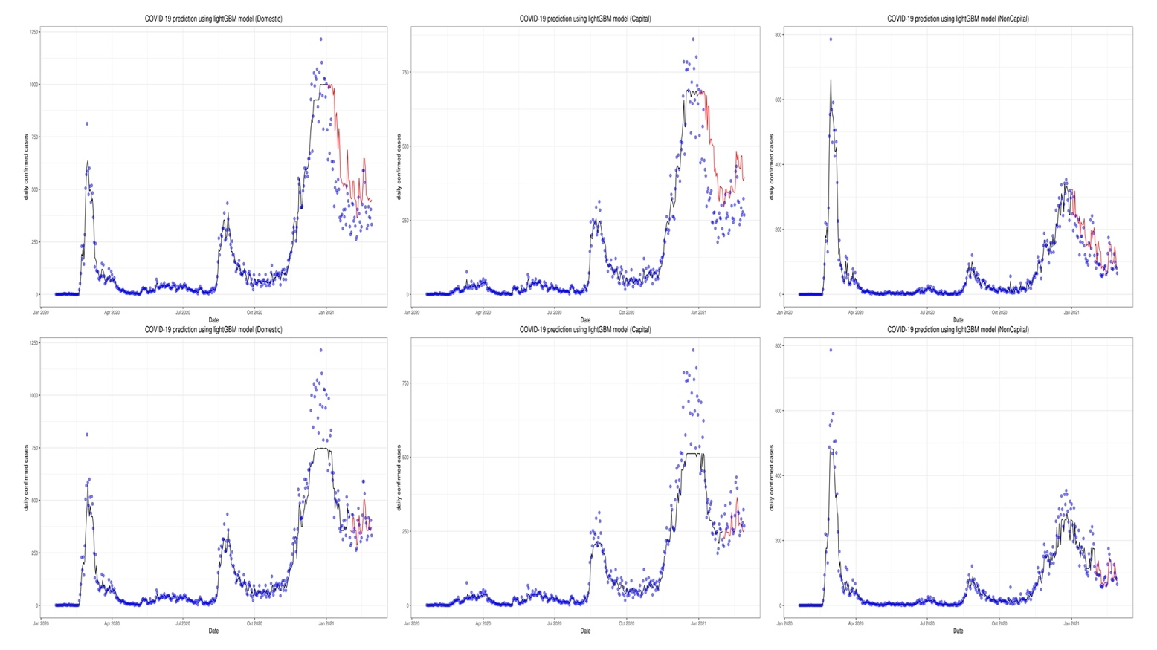
Supplementary Fig. 8. Prediction of the coronavirus disease 2019 (COVID-19) situation for the three regions with the first and second data subset using gradient boosting machine (GBM).

