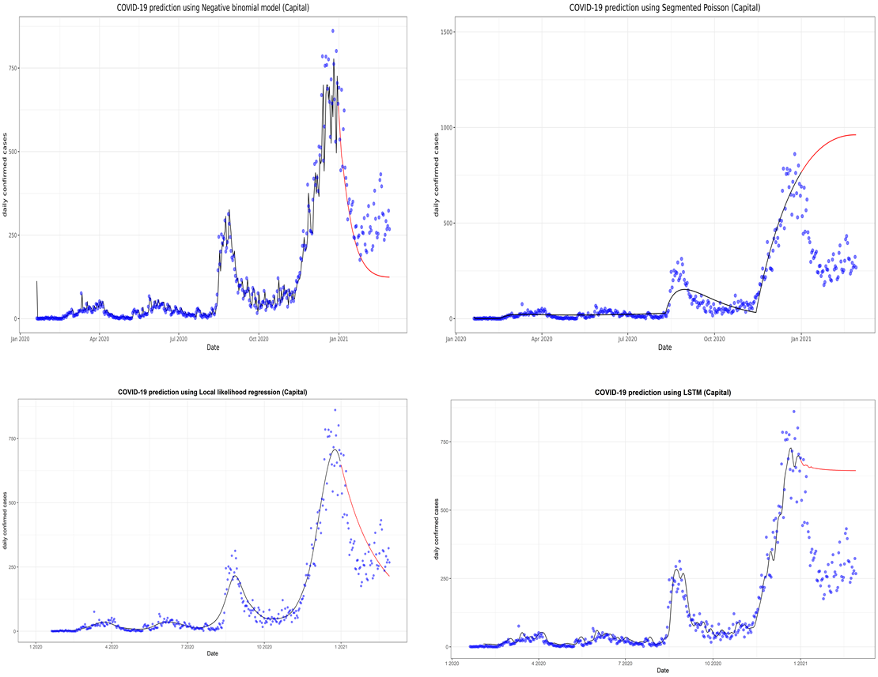
Supplementary Fig. 2. Prediction of the coronavirus disease 2019 (COVID-19) situation for the Capital region with the first data subset. LSTM, long short-term memory.

