Supplementary Table 17. RNA hybrid analysis of miRNAs (present in at least three breast cancer cell lines) target genes (17 luminal-A and 15 triple-negative breast cancer) previously reported to have role in breast cancer

miRNA | Putative target gene | RNAhybrid result | Binding energy (kcal/mol)
miR5787 | RERG | 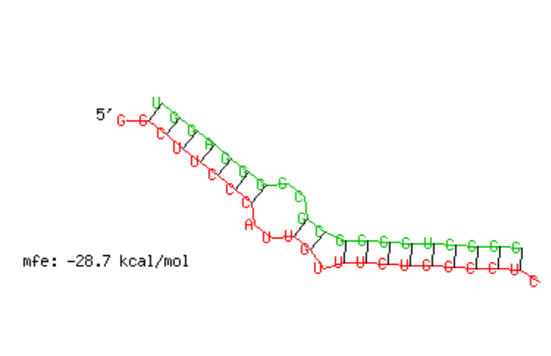 | -28.7
miR5787 | IGFBP6 |  | -37.7
miR6791 | BMF | 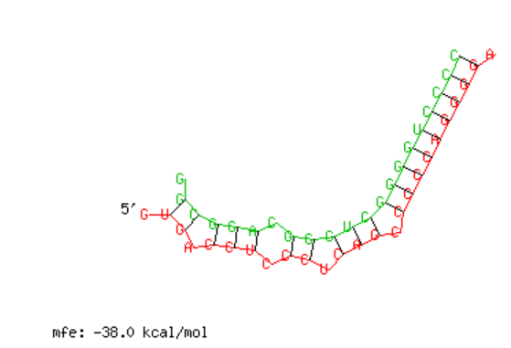 | -38.0
miR5787 | BMF |  | -35.6
miR4512 | BMF | 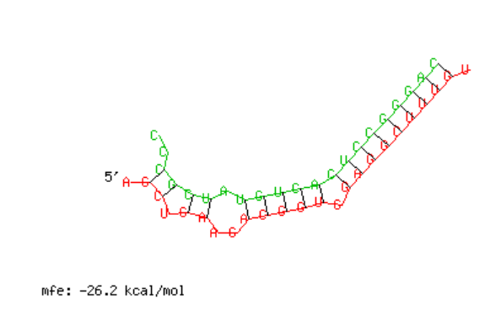 | -26.2
miR3613 | IQGAP2 | 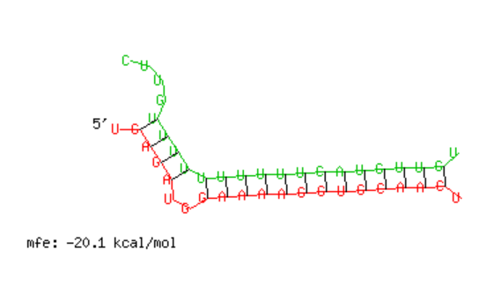 | -20.1
miR5787 | TNFSF10 | 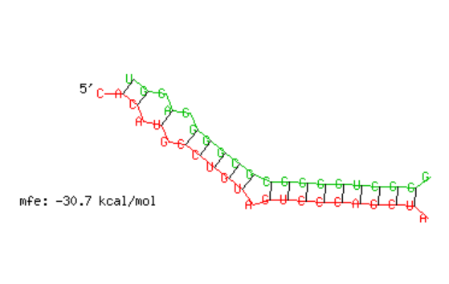 | -30.7
miR3180 | FAT4 | 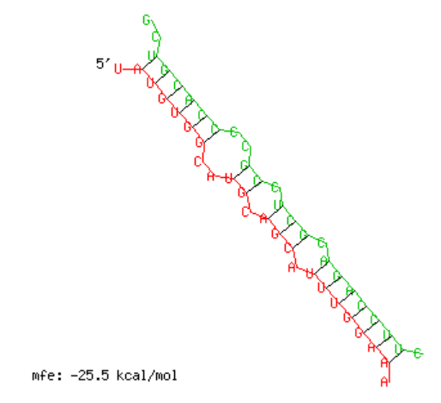 | -25.5
miR330 | STC2 | 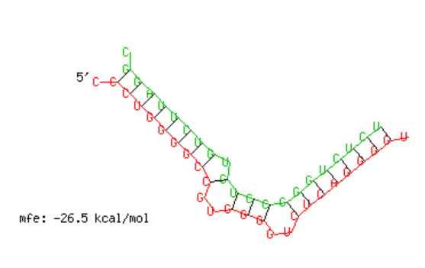 | -26.5
miR6791 | STC2 |  | -33.6
miR5787 | STC2 |  | -32.5
miR5787 | ZNF655 | 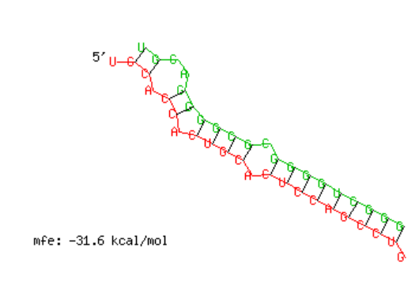 | -31.6
miR5787 | AXL |  | -28.3
miR6791 | FXYD5 |  | -29.0
miR330 | FXYD5 | 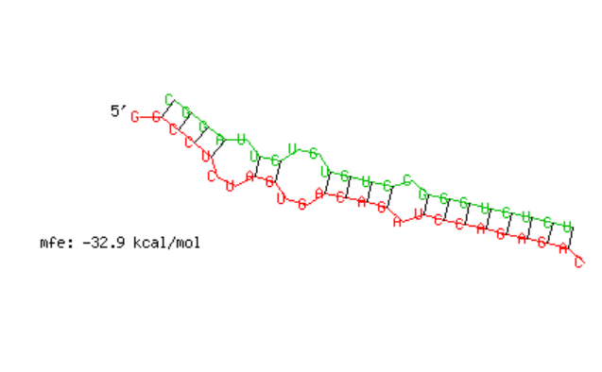 | -32.9
miR5787 | FXYD5 |  | -34.5
miR6791 | PTRF | 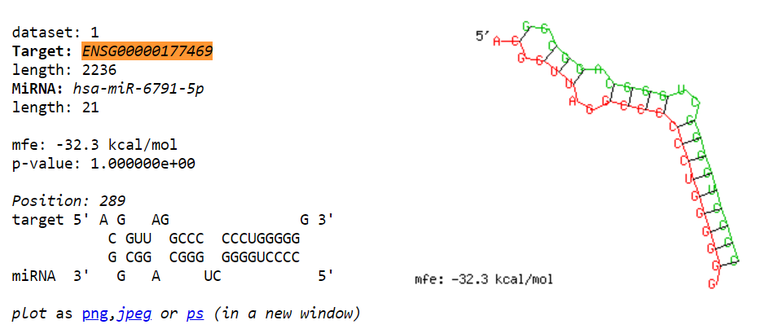 | -32.3
miR330 | PTRF | 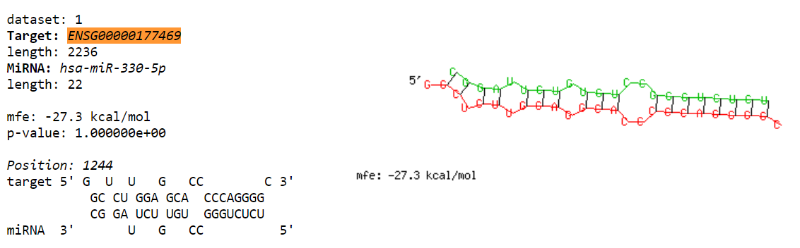 | -27.3
miR5787 | PTRF | 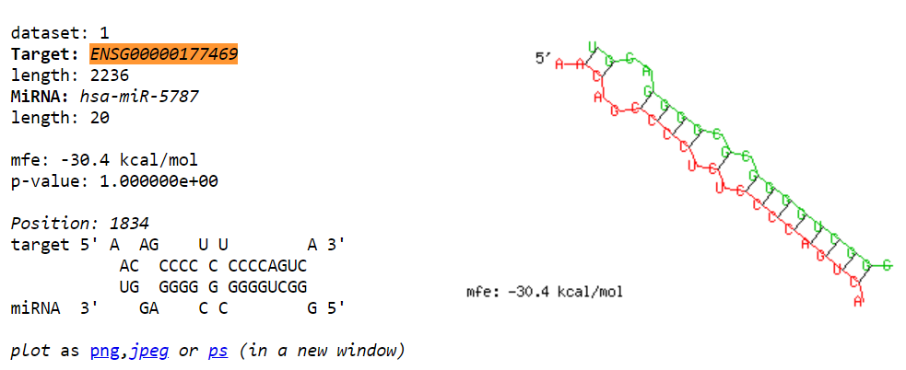 | -30.4
miR5787 | RUNX2 |  | -29.6
miR6791 | RUNX2 |  | -34.0
miR5787 | SPATA18 | 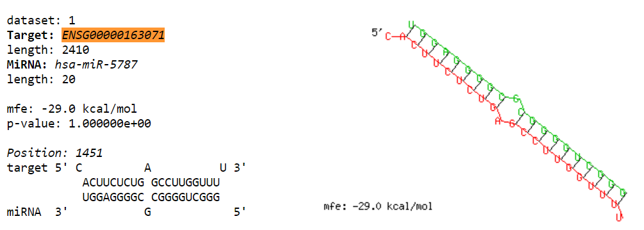 | -29.0
miR5787 | UGT8 | 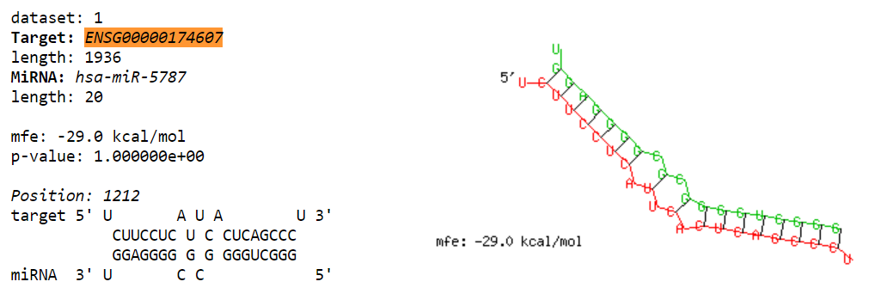 | -29
miR6791 | UGT8 |  | -27.1
miR3613 | UGT8 |  | -18.3
miR5787 | TMEM47 |  | -32.2
miR5787 | NUPR1 | 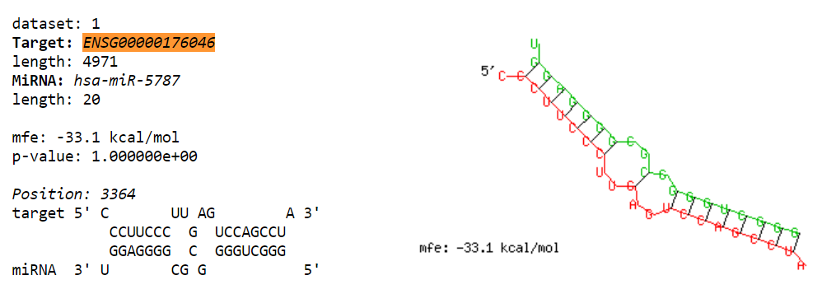 | -33.1
miR3180-3 | NUPR1 | 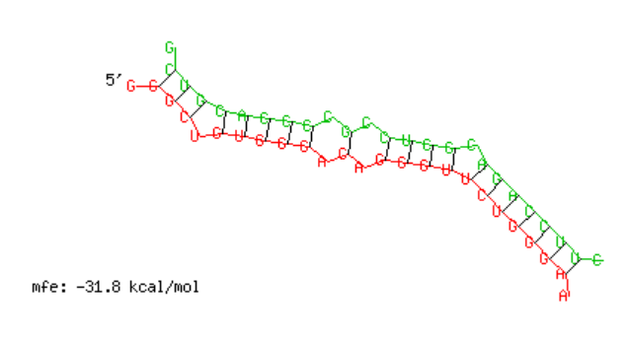 | -31.8
miR330 | NUPR1 | 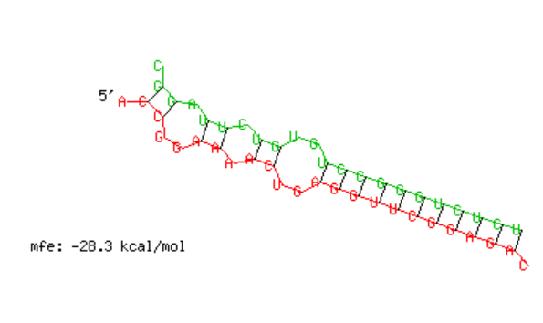 | -28.3
miR6791 | NUPR1 | 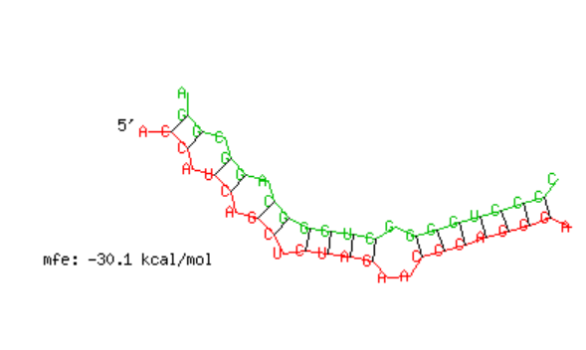 | -30.1
miR5787 | HOXC13 | 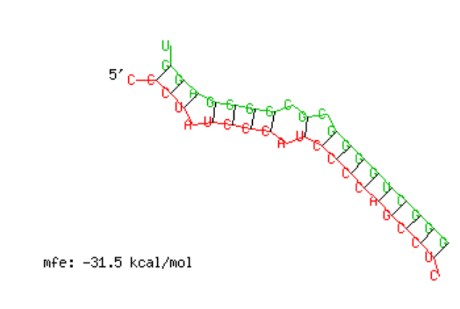 | -31.5
miR330 | HOXC13 | 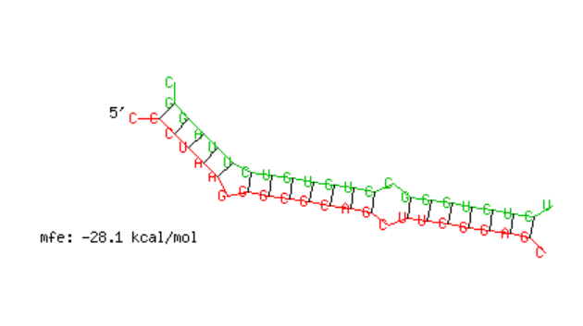 | -28.1
miR4512 | PRRX1 |  | -30.2
miR5787 | PRRX1 | 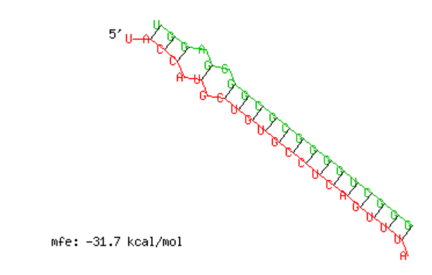 | -31.7
miR6791 | PRRX1 | 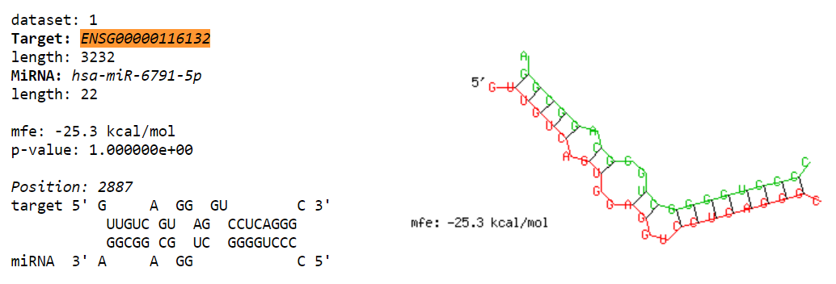 | -25.3
miR3613 | PRRX1 | 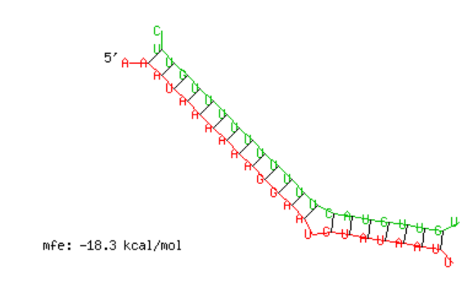 | -18.3
miR330 | CFB | 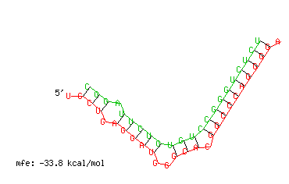 | -33.8
miR5787 | CFB |  | -25.3
miR6791 | CFB |  | -29.6
miR330 | CSF3 | 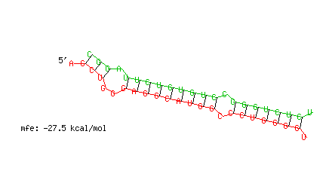 | -27.5
miR4512 | CSF3 | 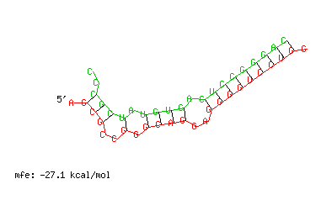 | -27.1
miR6791 | CSF3 |  | -27.2
miR330 | HEG1 | 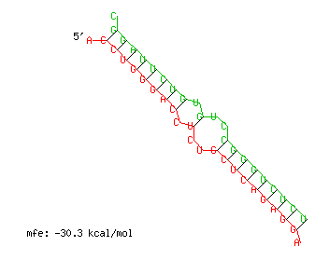 | -30.3
miR3180-3 | HEG1 |  | -25.9
miR5787 | HEG1 | 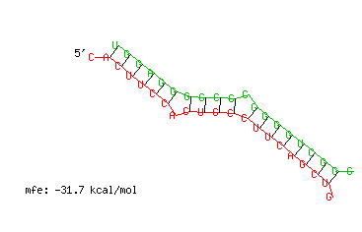 | -31.7
miR6791 | HEG1 | 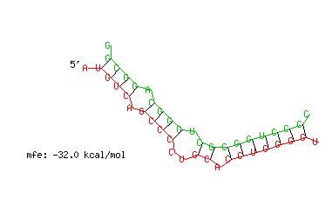 | -32.0
miR3180-3 | PLAU | 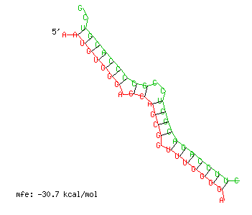 | -30.7
miR5787 | PTER | 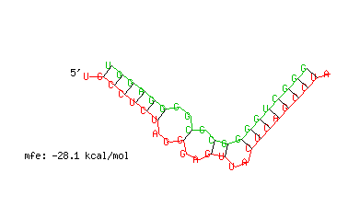 | -28.1
miR330 | S100A3 |  | -29.7
miR3180-3 | S100A3 |  | -30.7
miR4512 | S100A3 |  | -28.8
miR5787 | S100A3 | 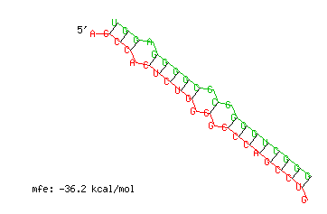 | -36.2
miR6791 | S100A3 |  | -30.3
miR4512 | SNURF |  | -30.0
miR6791 | SNURF |  | -30.2
miR3180-3 | WIPF1 |  | -27.3
miR3613 | WIPF1 |  | -18.4
miR5787 | WIPF1 |  | -26.6
miR6791 | WIPF1 |  | -31.3
miR6791 | AC108941.2 | 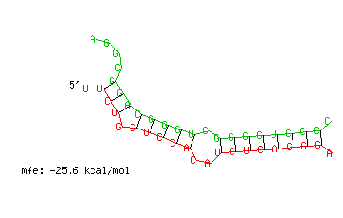 | -25.6
miR330 | ADAMTSL1 |  | -29.1
miR3613 | ADAMTSL1 |  | -18.6
miR5787 | ADAMTSL1 |  | -34.6
miR6791 | ADAMTSL1 |  | -34.7
miR330 | ARHGEF5 | 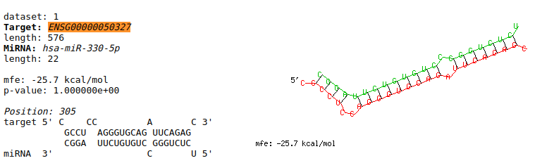 | -25.7
miR5787 | ARHGEF5 | 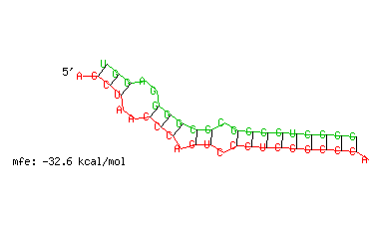 | -32.6
miR6080 | ARHGEF5 |  | -34.1
miR330 | BNC1 |  | -26.0
miR5787 | BNC1 |  | -33.0
miR6791 | BNC1 | 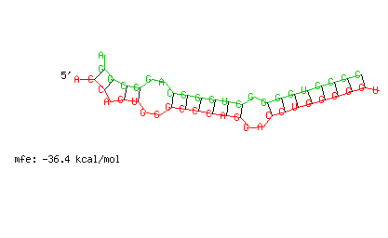 | -36.4
miR5787 | CPA4 |  | -34.5
miR5787 | PPL |  | -28.6
miR5787 | TNFRSF10D |  | -35.4
miR6733 | TNFRSF10D |  | -26.2
miR6791 | TNFRSF10D |  | -27.4

