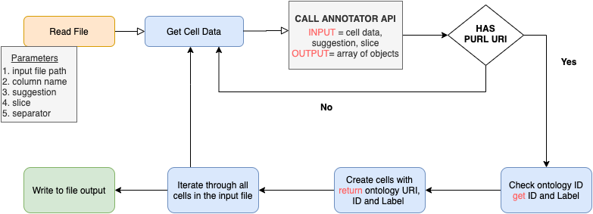

S1: Operation Diagram for Table2Annotation tool

