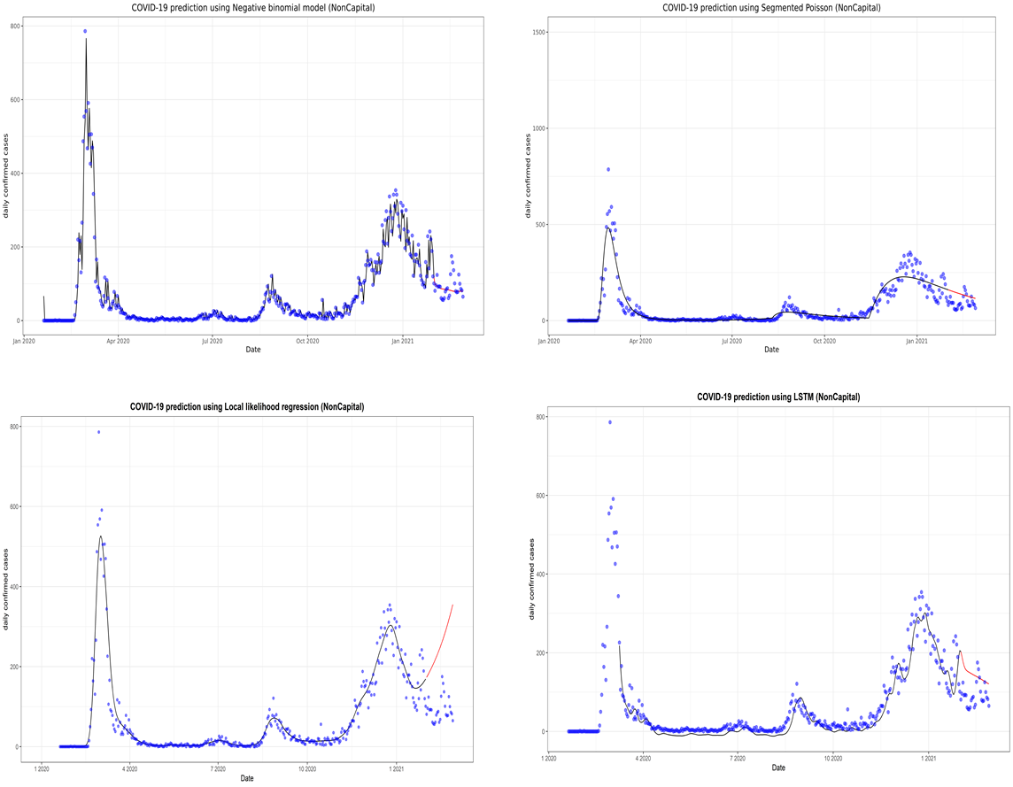
Supplementary Fig. 6. Prediction of the coronavirus disease 2019 situation for the non-capital region with the second data subset. LSTM, long short-term memory.

