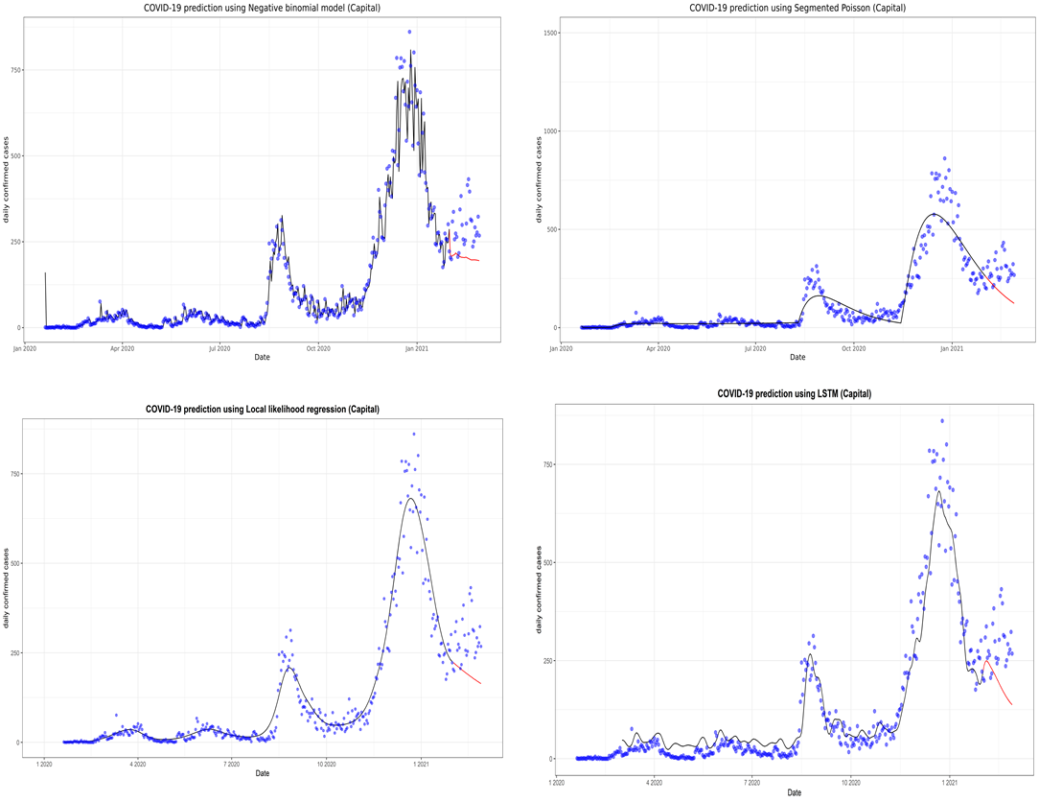
Supplementary Fig. 5. Prediction of the coronavirus disease 2019 (COVID-19) situation for the capital region with the second data subset. LSTM, long short-term memory.

