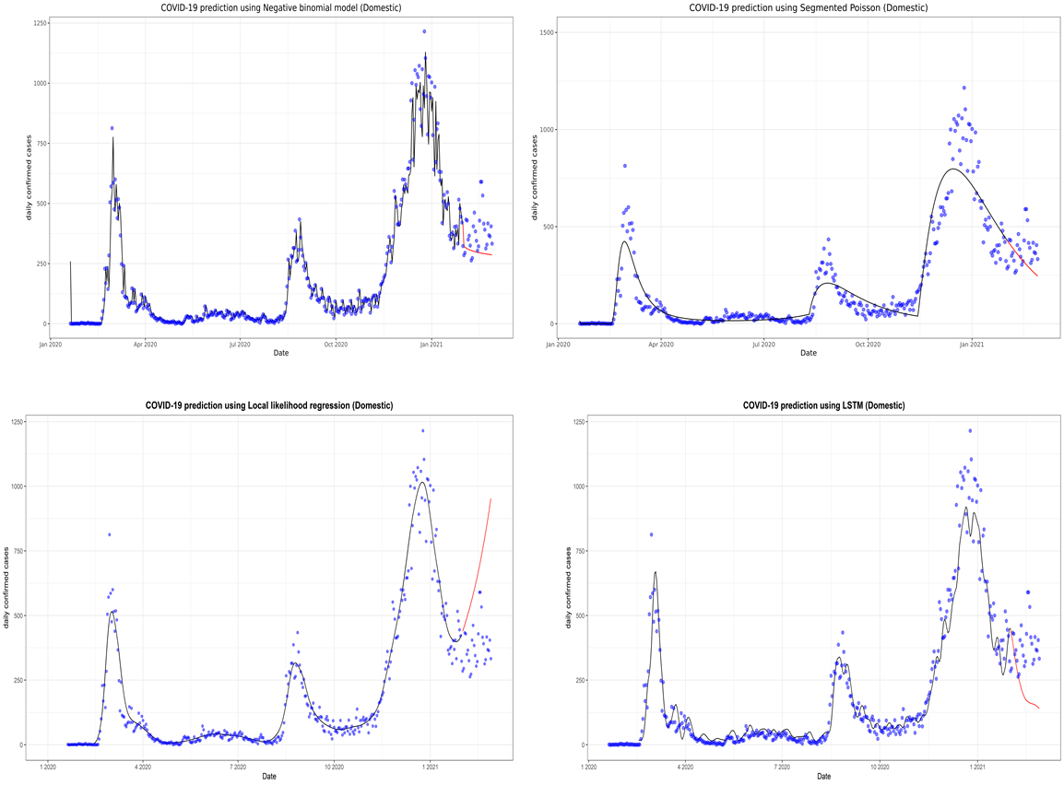
Supplementary Fig. 4. Prediction of the coronavirus disease 2019 (COVID-19) situation for the domestic region with the second data subset. LSTM, long short-term memory.

