Supplementary Table 8. RNA hybrid analysis of triple-negative breast cancer exclusive miRNA target genes
miRNA | Putative target gene | RNA hybrid result | Binding energy (kcal/mol)
TNBC - Thirteen gene targets by miRNAs
miR4767 | STC2 |  | -30.6
miR4767 | FOXL2 |  | -35.8
miR4767 | MGAT4C | 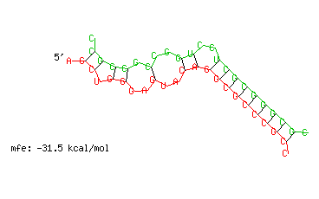 | -31.5
miR4487 | CPA4 |  | -32.5
miR4487 | ATP13A4 |  | -26.4
miR4487 | ADAMTSL1 |  | -25.1
miR4487 | SPOCK2 | 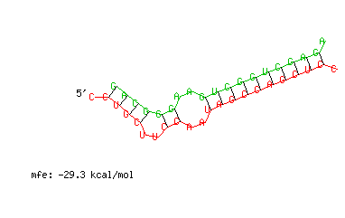 | -29.3
miR4487 | FOXL2 |  | -26.5
miR6720 | GAL3ST3 |  | -30.5
miR6720 | NFE2 |  | -30.1
miR6720 | NUPR1 |  | -27.1
miR6720 | FOXL2 | 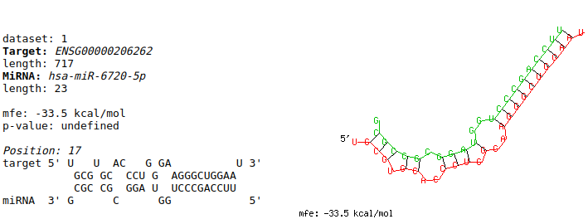 | -33.5
miR6720 | EPHA3 |  | -28.0
miR6720 | COL25A1 |  | -33.3
miR-LET7i | C1orf228 | 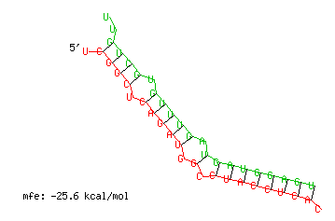 | -25.6

